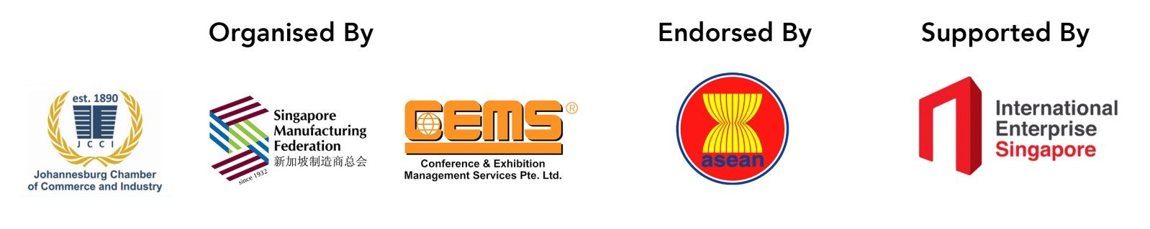
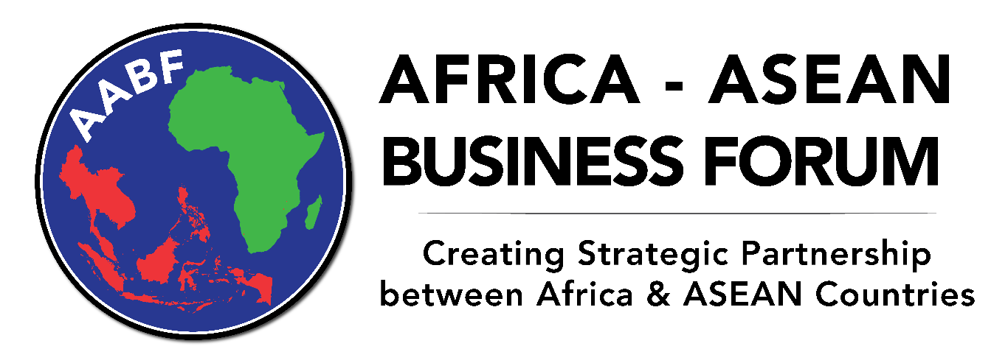
Sandton Convention Centre, Johannesburg
6 – 7 November 2017
The Africa – ASEAN Business Forum aims to foster cooperation between local businesses and their ASEAN (Association of Southeast Asian Nations) counterparts.
The ASEAN bloc offers opportunities in strategic sectors such as automotive, textiles, mining, healthcare, financial services, agriculture, e-commerce, energy, transportation, logistics, tourism, science and technology.
Day 1: 6 November 2017, 13:30 – 18:30
Time | Agenda
13:30 | Delegate Registration
14:15 | Opening Remarks  Dr Martyn Davies, Programme Director  Managing Director of Emerging Markets & Africa  Deloitte South Africa
14:25 | Welcome Address  Mr Herman Breedt  President  Johannesburg Chamber of Commerce and Industry
14:30 | Welcome Address  Mr Douglas Foo, BBM  President, Singapore Manufacturing Federation &  Appointed Member, ASEAN Business Advisory Council
14:40 | Keynote Address  Mr Bulelani Gratitude Magwanishe  Honourable Deputy Minister of Trade and Industry of South Africa
14:50 | Signing of Memorandum of Understanding between Johannesburg Chamber of Commerce and Industry and Singapore Manufacturing Federation
15:00 | Presentations and Panel Discussion  Moderator: Dr Martyn Davies, Deloitte South Africa  Presenters & Panellists:  - Mr Douglas Foo, BBM  President, Singapore Manufacturing Federation &  Appointed Member, ASEAN Business Advisory Council  - Ms Lisa Xie  Head of FNB Business China  First National Bank  - Mr Evance Chanda  Director  Southern Africa Zambia Chamber of Commerce and Industry
16:30 | Visit to Africa-ASEAN Business Expo 2017
17:00 | Cocktails & Networking Session
18:30 | End of Day 1

Day 2: 7 November 2017, 08:30 – 16:45
Time | Agenda
08:30 | Delegate Registration / Tea & Coffee
09:00 | Presentation by High Commission of the Republic of Singapore in South Africa  Country Overview, Bilateral Trade Opportunities, Trade/Investment Policies & Opportunities  Ms Faridah Mohd Saad  Second Secretary (Commercial) / Centre Director (Johannesburg), International Enterprise Singapore
09:30 | Presentation by InvestSA  Ambassador Sadick Jaffer  Chief Director: Investment Promotion
10:00 | Presentation by Embassy of the Republic of Philippines in South Africa  Country Overview, Bilateral Trade Opportunities, Trade/Investment Policies & Opportunities  Mr Joselito Chad Jacinto  Second Secretary and Consul
10:30 | Presentation by Republic of Ghana  Opportunities in Ghana’s Export Sector for Potential Investors  Ms Gifty Klenam  CEO, Ghana Export Promotion Authority
11:00 | Tea & Coffee
11:30 | Presentation by Embassy of the Republic of Indonesia in South Africa  Country Overview, Bilateral Trade Opportunities, Trade/Investment Policies & Opportunities  H E Mr Suprapto Martosetomo  Ambassador of the Republic of Indonesia
12:00 | Presentation by Richards Bay Industrial Development Zone Company SOC Ltd  Richards Bay Industrial Development Zone: Investment Opportunities  Mr Mzamo Khuzwayo  Executive Manager: Business Development and Support
12:30 | Networking Lunch
13:30 | Presentation by High Commission of Malaysia in South Africa  Country Overview, Bilateral Trade Opportunities, Trade/Investment Policies & Opportunities  Mr Mohamed Hafiz Md Shariff  Trade Commissioner, Malaysia External Trade Development Corporation
14:00 | Presentation by High Commission of the Republic of Rwanda in South Africa  H E Mr Vincent Karega  High Commissioner of the Republic of Rwanda
14:30 | Presentation by Embassy of the Socialist Republic of Vietnam in South Africa  Country Overview, Bilateral Trade Opportunities, Trade/Investment Policies & Opportunities  H E Mr Vu Van Dzung  Ambassador of the Socialist Republic of Vietnam
15:00 | Presentation by Royal Thai Embassy in South Africa  Country Overview, Bilateral Trade Opportunities, Trade/Investment Policies & Opportunities  Mr Paisit Boonparlit  Chargé d'Affaires
15:30 | Presentation by Kingdom of Cambodia  Economic Development and Investment Opportunities in Cambodia  Mr Rath Saravuth  Deputy Director General for International Trade, Ministry of Commerce
16:00 | Closing Remarks  Dr Martyn Davies  Managing Director of Emerging Markets & Africa  Deloitte South Africa  Mr Edward Liu, PBM  Group Managing Director  Conference & Exhibition Management Services Pte Ltd
16:15 | Tea & Coffee
16:45 | End of Day 2
Cost for the two-day Business Forum:
R499 members / R899 non-members

For bookings / more information, please contact:
Melitta Openshaw, melitta@jcci.co.za / 011 726 5300
